Professional Development Workshop: Basic Video Creation (3-part series)

Speaker: Denny Dupps, Cincinnati Engineering Enhanced Mathematics and Science Program (CEEMS) Resource Team Member
Date: July 9, 2018; July 12 2018; July 19, 2018
Time: 10:30 AM – 12:00 PM; 11:00 AM – 12:00 PM; 10:30 AM-12:00 PM
Venue: University of Cincinnati, Swift Hall, Room 608

Prepared by:
Kelly Hiersche, Middlesboro High School, Middlesboro, KY
RET Participant for Project #5: Cybersecurity

Mr. Dennis Dupps presented three sessions on video creation. Mr. Dupps currently serves as the Technology Resource person for the CEEMS grant at UC. He earned his BS in Industrial Arts Education at Morehead State University and a Masters in Secondary Education from UC, as well as, additional coursework in Information Technology, Computer Science, Digital Video Productions and Robotics. He has been a high school technology teacher at Indian Hills High School for the past 49 years and served as the President of the Ohio Technology Education Association from 1984-86. He continues to teach part time at Indian Hills High School and is the faculty advisor of the Indian Hills Television Network, which produces a weekly news program and many sports and musical programs throughout the district. These three sessions were presented with the goals of teaching basic video making tools and clarifying the requirements for the end of summer video and unit video which RET teachers are responsible for creating.
In the first session, Mr. Dupps provided a tutorial on creating videos using Microsoft PowerPoint. Slideshow presentations can be saved as video (.mpeg4) file and if transitions, animations and voice recordings are used in the presentation, the presentation will mimic a video created in more complex software applications, such as Movie Maker or DaVinci Resolve. The format of this presentation was as follows: Mr. Dupps created a PowerPoint presentation, which included screenshots and clear steps for the RET teachers to follow as they created a practice video. He provided all of the media necessary for teachers to accomplish this (see Figure 1), he presented five to six development steps at a time, modeled the process on the screen, and then gave time for the RET teachers to make the video themselves.

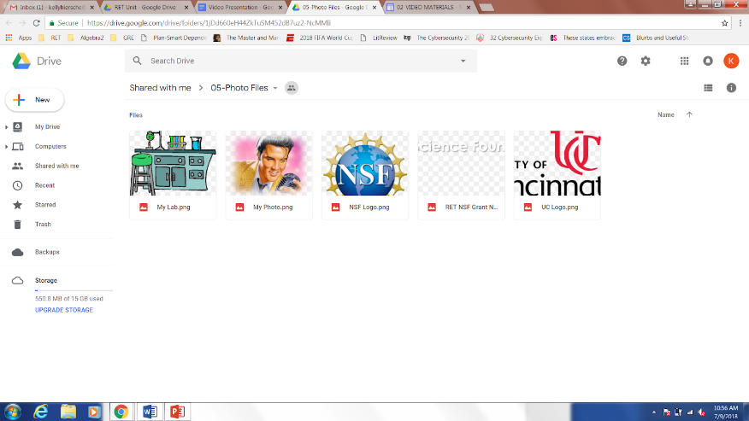

Figure 1: Screenshot of the media teachers downloaded to create the practice video

Overall, the goal of the first session was to teach basic skills needed for video creation in PowerPoint. RET teachers learned how to create a video, use animation techniques, make slide transitions, use adjusted slide transition timing, insert a voiceover and video clip, create moving credits, save as a video file, and upload videos to YouTube and wikisites. Each RET teacher ended this session with a PowerPoint presentation saved as a video (see Figure 2).
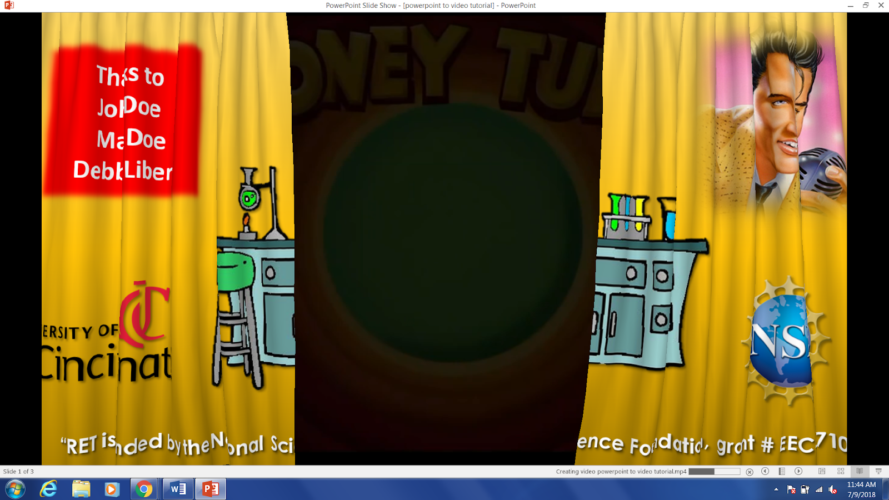

Figure 2: Screenshot of video created by RET Participants during the first video making session

During the second session, Mr. Dupps introduced the video editing software Movie Maker and advised that teachers use a combination of various video editing software to create their videos. The format of this presentation was similar to the first session; Mr. Dupps explainedand, modeled the steps, and then allowed teachers to try each step on their own, while answering any questions. The goal of this session was to learn how to adjust and combine videos, pictures and audio. The Movie Maker software gives the user more control of the volume and it is easier to cut video and audio tracks which is helpful for shortening videos.
At the conclusion of the second session the RET teachers were able to use their video from first session one and expand it into a longer video using Movie Maker. As well, teachers were shown how to convert a YouTube video clip to a file that could be downloaded into MovieMaker (see Figure 3), and combine with the previously created video. Mr. Dupps also provided a variety of resources for finding sound clips for use in the background of the videos. All teachers were able to practice downloading and overlaying a sound track in their MovieMaker videos. Everyone left this session with a partially created, practice video, created in MovieMaker and with clear, concise steps for finishing this video and creating future videos.
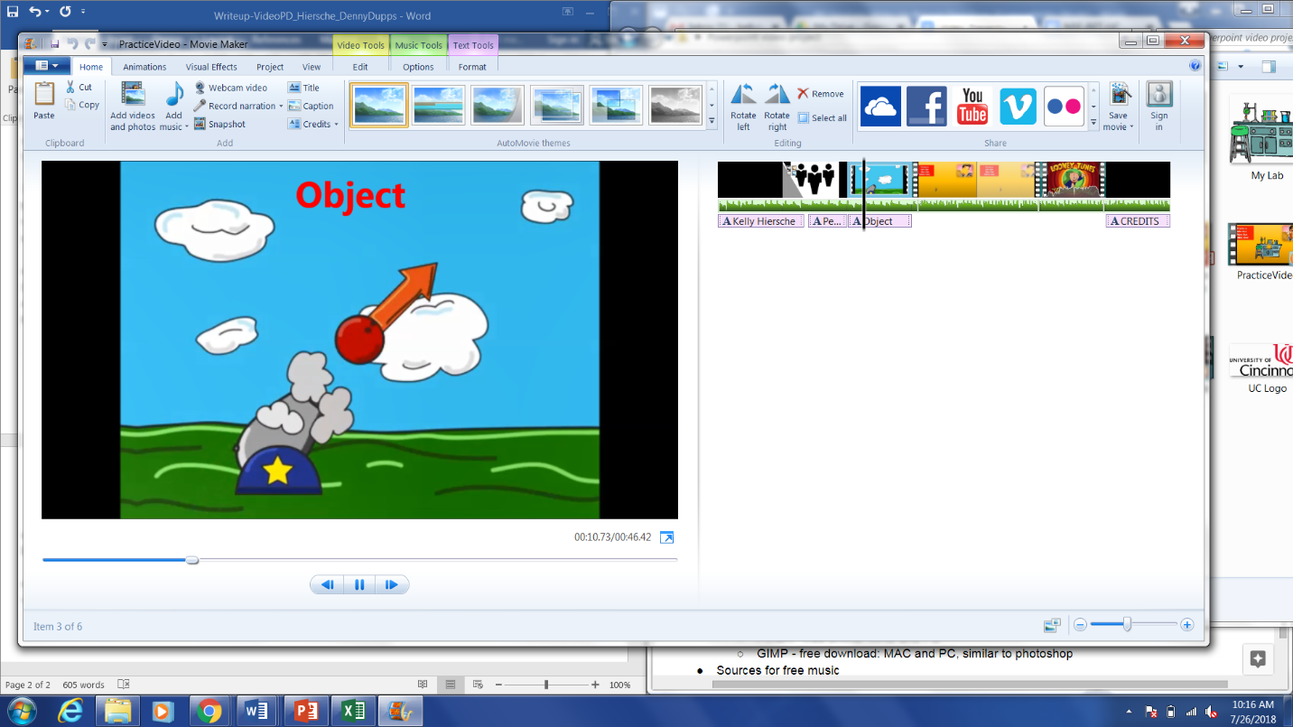
Figure 3: Screenshot of the video clip downloaded from YouTube inserted into Movie Maker.

The third video workshop session provided invaluable information about video requirements for the end of summer video and the unit video. Mr. Dupps spent most of the session talking aboutthe unit video, because teachers will be preparing these videos by themselves, , with less access to RET personnel. To ensure teachers were well prepared, Mr. Dupps used this session to answer an questions, clarify requirements, and provide teachers with an extensive list of resources which are available to them while creating their videos. Some of these resources included PIXLR, GIMP, www.bensound.com, and www.purple-plant.com. Additionally, Mr. Dupps gave teachers general advice for making quality movies such as: see what you say, say what you see; keep eyes in the top third of the frame; use a tripod when filming; and when possible, use a microphone for interviews,. Mr. Dupps ended the final presentation by giving all RET teachers his contact information.

